Birchlands Crown Crusader at Sailema  Rider  Sex: Dog  DOB: 8th Jan 2010  Reg.no: 02289-2010  Color: Liver and White  Breeder(s): B Nolan & A Wickstead  Owner(s): Barbara Nolan/Amelia Nolan Wickstead  Phone: +0064 3 3822586  Email: info@outside-inside.co.nz  Internet: www.sailemawebs.com | 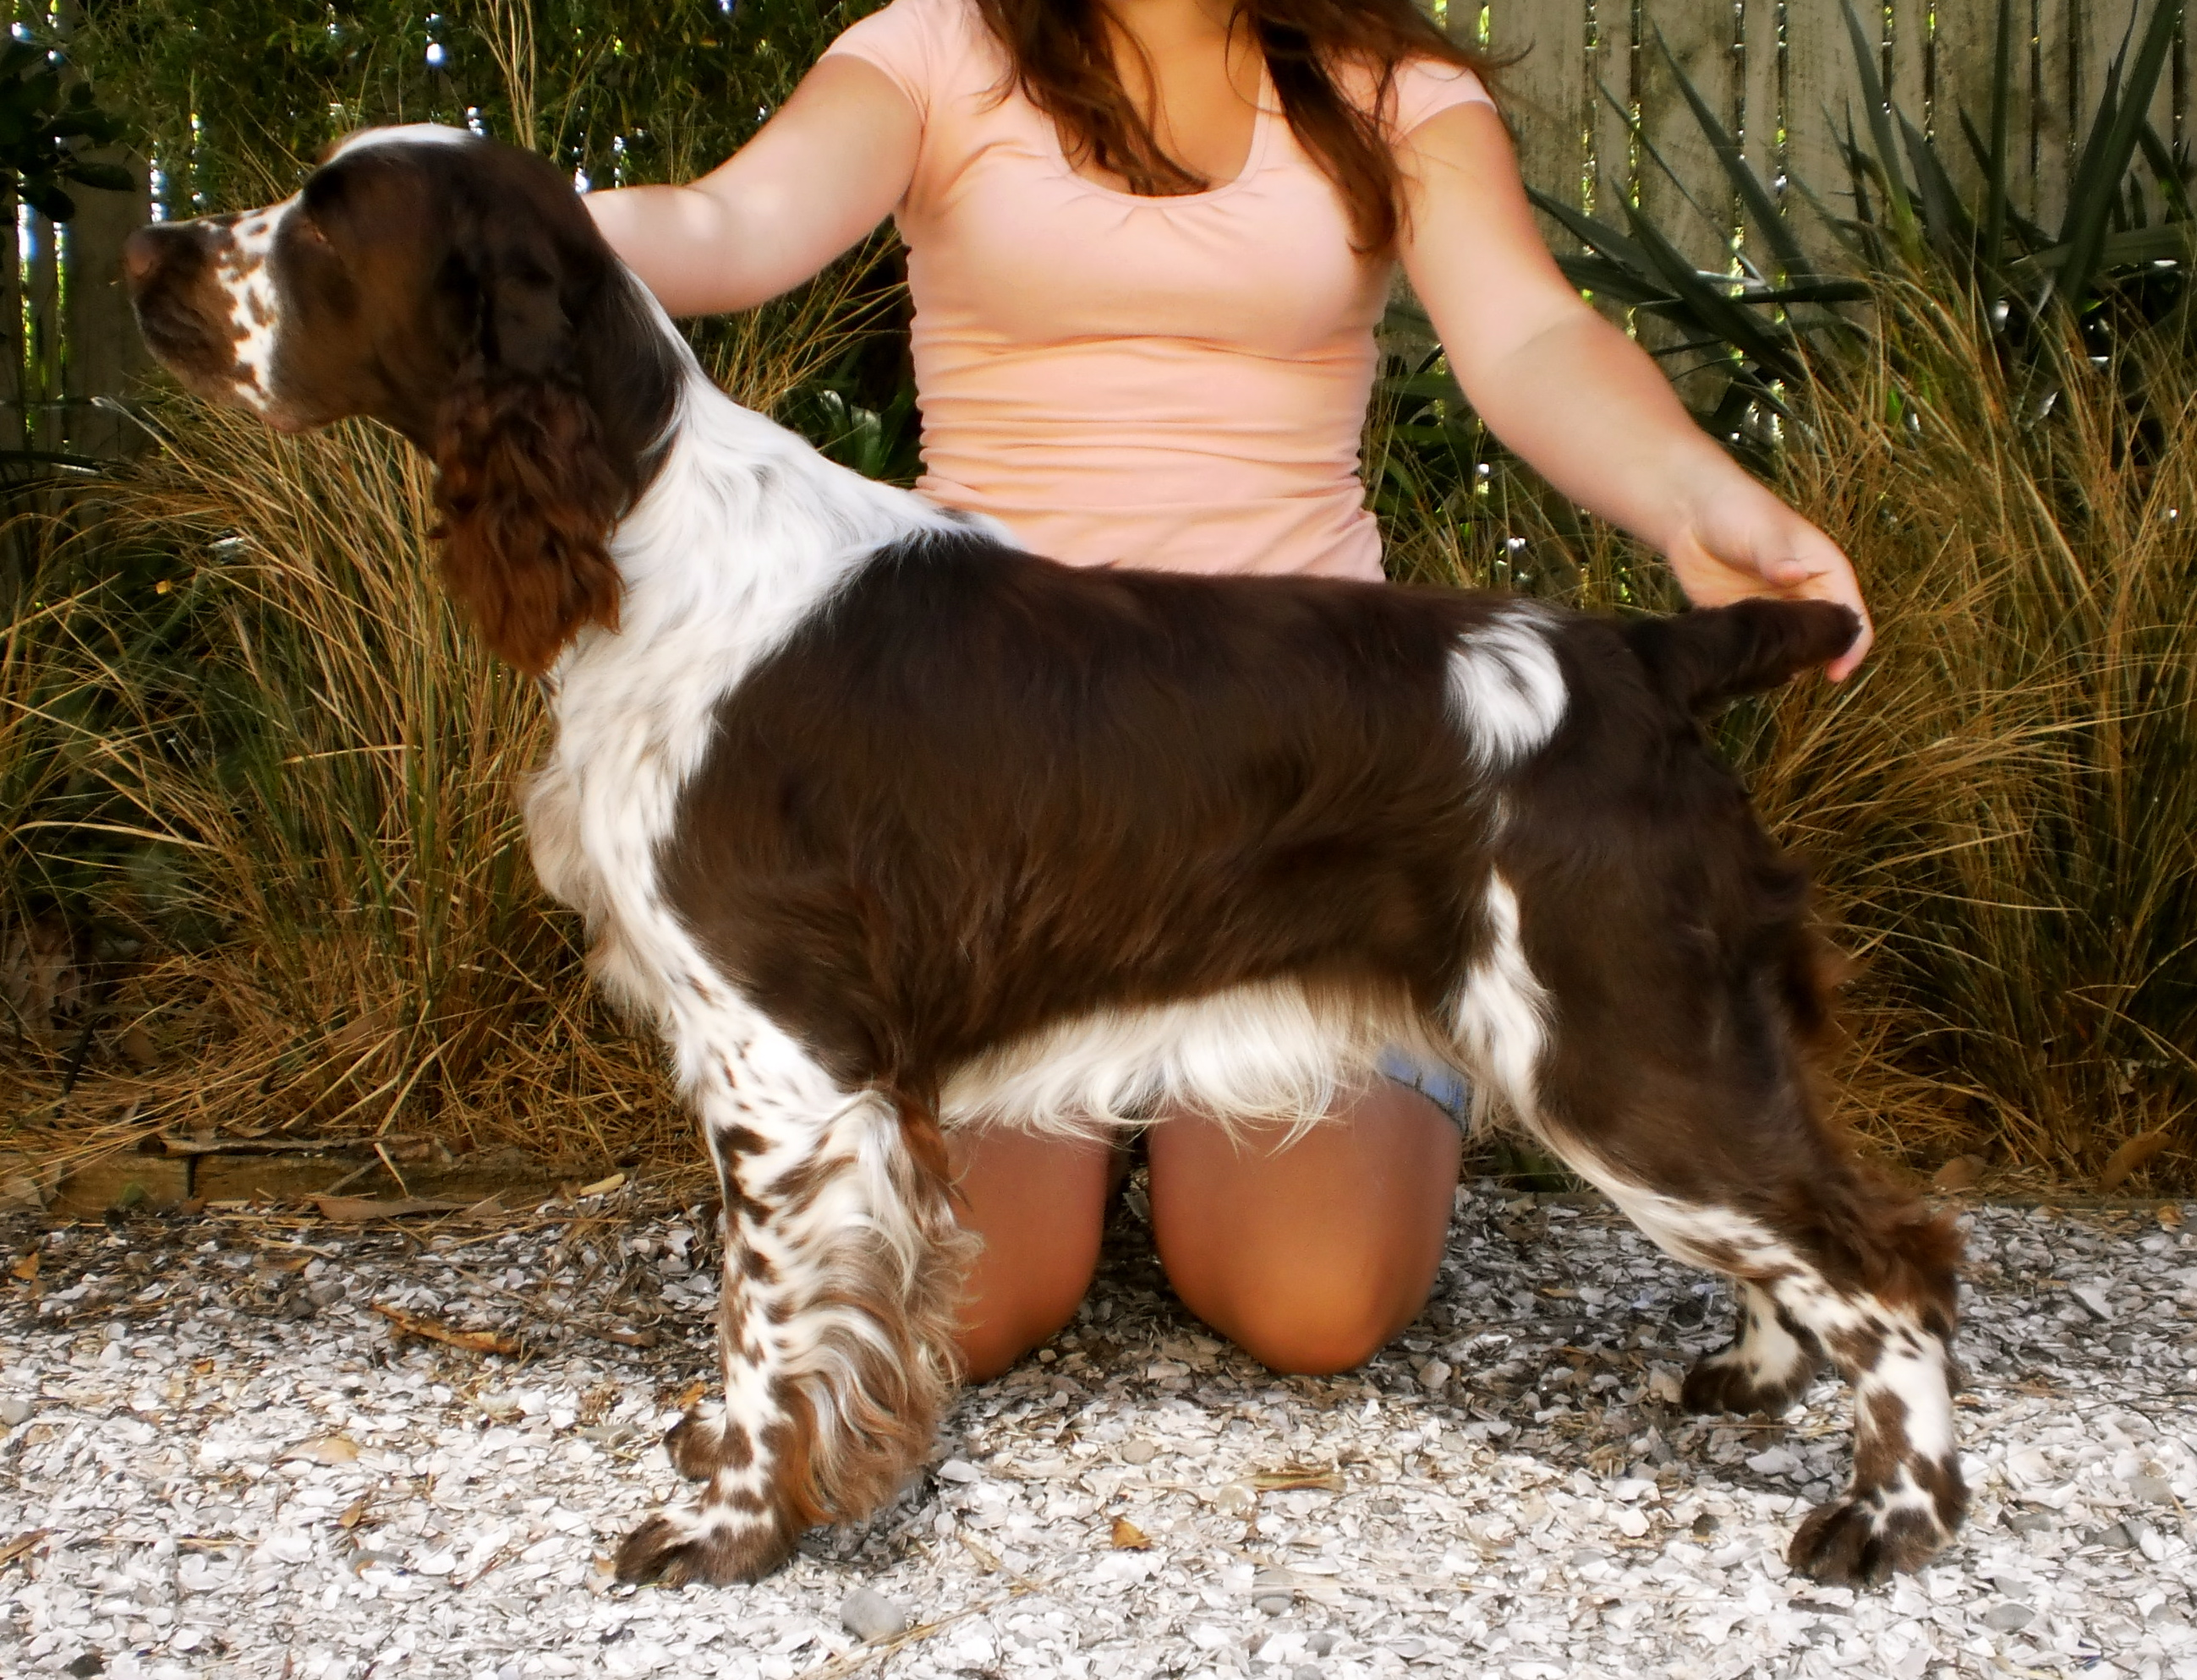

PARENTS | GRANDPARENTS | GREAT GRANDPARENTS | GREAT GREAT GRANDPARENTS
NZ CH Sailema Just D Bomb | NZ CH Sailema Just The Ticket | Aust & Isr Ch Mompesson Gigolo ( Imp Uk) | Eng Sh Ch Mompesson Just The Ticket
NZ CH Sailema Just D Bomb | NZ CH Sailema Just The Ticket | Aust & Isr Ch Mompesson Gigolo ( Imp Uk) | Mompesson Sweet and Smart
NZ CH Sailema Just D Bomb | NZ CH Sailema Just The Ticket | NZ Ch Sailema Golddust Sailema Lilly | Trulock Phroiag
NZ CH Sailema Just D Bomb | NZ CH Sailema Just The Ticket | NZ Ch Sailema Golddust Sailema Lilly | NZ Ch Rolled N Gold O Hollywell
NZ CH Sailema Just D Bomb | Abbotsgate Venetia ( Imp Aust) | Eng Sh Ch Mompesson Royal Destiny | Eng Sh Ch Mompesson Blinking Hell
NZ CH Sailema Just D Bomb | Abbotsgate Venetia ( Imp Aust) | Eng Sh Ch Mompesson Royal Destiny | Eng Sh Ch Trimere Time to Remember
NZ CH Sailema Just D Bomb | Abbotsgate Venetia ( Imp Aust) | Aust Ch Blackfriar Cleopatra | Aust Ch Clanach Coup D Etat
NZ CH Sailema Just D Bomb | Abbotsgate Venetia ( Imp Aust) | Aust Ch Blackfriar Cleopatra | Blackfriar Aliya ( Imp Isr)
NZ CH Birchlands Crowning Glory | NZ CH Clanach Crown Insigna (Imp Aust) | Aust Ch Clanach Union Jack | Eng Sh Ch Graftonbury Gengis Khan(imp Uk)
NZ CH Birchlands Crowning Glory | NZ CH Clanach Crown Insigna (Imp Aust) | Aust Ch Clanach Union Jack | Hawkhill One In a Million (Imp Uk)
NZ CH Birchlands Crowning Glory | NZ CH Clanach Crown Insigna (Imp Aust) | Aust Ch Clanach Crown N Scepter | Aust Ch Timwhiskies I Gotta B me
NZ CH Birchlands Crowning Glory | NZ CH Clanach Crown Insigna (Imp Aust) | Aust Ch Clanach Crown N Scepter | Aust Ch Clanach Jewel N The Crown
NZ CH Birchlands Crowning Glory | CH Birchlands Stormy Plum | NZ /Aust Ch Hollycest Portina Storm (Import Aust) | Aust Ch Fairsky Hercule Poirot
NZ CH Birchlands Crowning Glory | CH Birchlands Stormy Plum | NZ /Aust Ch Hollycest Portina Storm (Import Aust) | Aust Ch Wongan Secret Seraph
NZ CH Birchlands Crowning Glory | CH Birchlands Stormy Plum | Ch Birchlands Kaffir Plum | NZ Ch Clanach Crown Insignia
NZ CH Birchlands Crowning Glory | CH Birchlands Stormy Plum | Ch Birchlands Kaffir Plum | NZ Ch Birchlands Kaffir Lilly

